**ACCESS FACILITIES – INSIDE THE EVENT**



There are limited hard standing paths in Victoria Park and are made worse by bad weather.

**Ticket Types and Collection**

The Accessible Areas are outside with very little shade.

C:\Users\darcey.jackson\AppData\Local\Microsoft\Windows\Temporary Internet Files\Content.IE5\7X5AG6YB\1343748940[1].png

**Viewing Platform at the Main Stage**

The Viewing Platform is designed for wheelchair users and other impairment groups where standing area is not suitable. (Subject to availability)

**Ground Level Viewing Area at the Main Stage**C:\Users\darcey.jackson\AppData\Local\Microsoft\Windows\Temporary Internet Files\Content.IE5\7X5AG6YB\1343748940[1].png

The Ground Level Viewing is for customers who have access needs but wish to stand, need a less crowded area and/or the option of sitting for short periods of time. (Subject to availability)

**Viewing Platform at Other Stages**

An unreserved place on the Viewing Platforms at other stages and valid with proof of disability. (Subject to availability)

**Personal Assistant Pass for Viewing Platform / Ground Level Viewing Area at the Main Stage**



The passes can be swapped with other members of a group.

All passes can be collected from the Info Point at the event by showing a ticket and proof of disability.

**Blue Badge Parking**



Free of charge and limited to one per paying customer. (Subject to availability)

Valid with blue bade, matching Photo ID and event ticket.

There is no exit from the car park between 8:30pm and 11:45pm.

**Facilities**

1. **Entrance**

There is a dedicated accessible lane at the main entrance at Crown Gate, on Grove Road.



1. **Access Manager**

You can find the Access Manager at the Info Hub, near the main entrance. This will be clearly signposted.

1. **Accessible Toilets**

Accessible toilets are at all toilet blocks, the Info Hub and the Viewing Platforms.

1. **Charging Points for Power Chairs**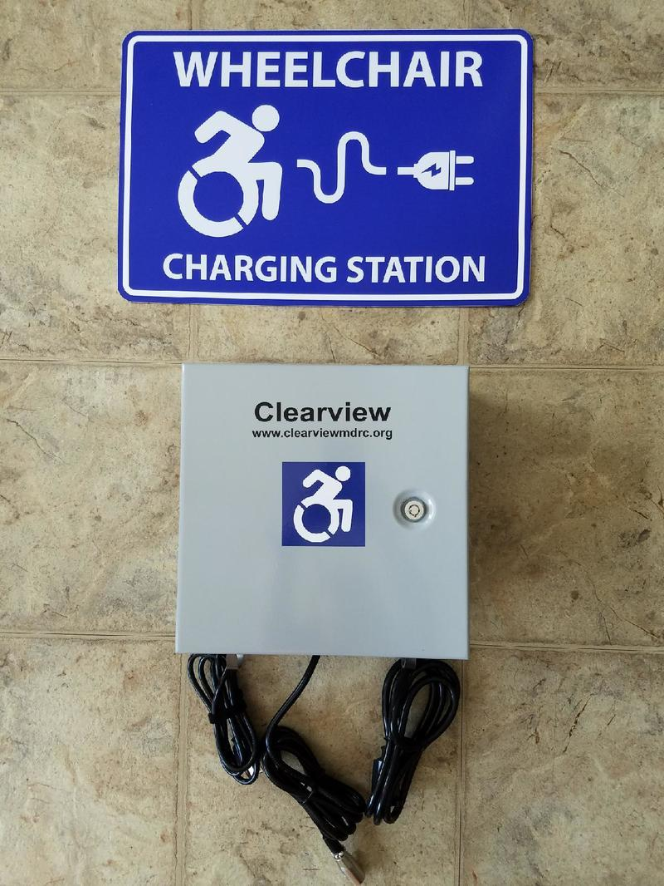

These are available at the Main Stage Viewing Platform

1. **Lowered Counters**

There will be lowered counters where possible at the box office, bars, merchandise stands, and some food outlets. Provisions will be made where they are not available.

1. **British Sign Language (BSL) Performance Interpreters**

BSL Performance Interpreters are available to request for all acts on the Main Stage. 

If you wish to request this, please email [access@allpointseastfestival.com](mailto:access@allpointseastfestival.com) no later than Friday the 24th June 2022.

1. **Hearing (Induction) Loops**

These are located at one of the Box Office windows, Info Point and limited bars locations.

1. **Merchandise**



Merchandise can be produced in alternative formats within a reasonable time frame.  Please email your request to [access@allpointseastfestival.com](mailto:access@allpointseastfestival.com)

1. **Quiet space**

This is a space that people can use when they need to get away from the crowd for a while. It is located in the Welfare Tent.

1. **Hidden Disabilities**

If you would like support or advice inside Luno presents All Points East our Access is based at the Info Point, near the main entrance. Or please contact us in advance with your questions [via access@allpointseastfestival.com](mailto:access@allpointseastfestival.com)

1. **A Dog Spending Area for Assistance Dogs**

If you require dog spending area on site, please email your request within a reasonable time frame to [access@allpointseastfestival.com](mailto:access@allpointseastfestival.com)

**Other Questions Around Accessibility**

Please contact us in advance via [access@allpointseastfestival.com](mailto:access@allpointseastfestival.com) any other questions which are not answered on the website.

**Medication**



Please bring any medication that you would normally take.  Medication can be safely stored and refrigerated at the event First Aid point on site if required.

Please remember that all medication must be self-administered.

**Strobe Lighting**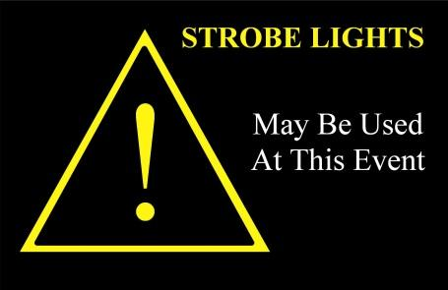

Please note that it is likely that most acts performing at the event will use strobe lighting as part of their performance.