

**All Points East 2025**

**Access Arrival Guide - Please Read Carefully**

This Access Arrival Guide is designed to give our access ticket holders information about the 2025 festival and what to expect once you arrive. This guide is available in large print and can be posted or emailed on request via any of the contact methods listed below.

Full information can be found in the [Accessibility Section of the All Points East website](https://www.allpointseastfestival.com/info-details/accessibility/#block-1).

The All Points East Access FAQs and Access Map can be downloaded from the [Accessibility Downloads Section of the All Points East website](https://www.allpointseastfestival.com/info-details/accessibility/#block-2).

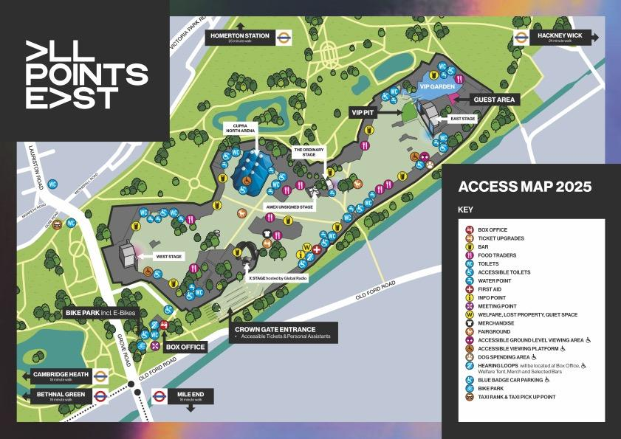

**Contact Us**

**By phone:** Accessibility Booking + Information line: 0344 581 0909. Opening hours are Mon - Fri, 9am - 5.30pm.

**By Live Chat:** You can contact us through AXS ‘Live Chat’ function in the help section on AXS website. To locate this, please go to www.axs.com/uk, travel to the bottom of the website, and click on the Help Centre link.

**By email:** You can also contact us by email on [access@allpointseastfestival.com](mailto:access@allpointseastfestival.com). We aim to respond within 5 working days.

**During the Event:** Our Access Manager will be based at First Aid & Welfare. They will be contactable via radio during the event so please speak to any member of staff if you need assistance.

# 

# Travel Info

**Address:** **All Points East Festival, Victoria Park, Grove Road, London E3**

All Points East takes place in Victoria Park. It is located in the borough of Tower Hamlets in the East End of London.

**Train & Tube**

The nearest step free station is Hackney Wick, which is served by the Overground and is 321 metres away from the event entrance.

**Bus**

Buses 8, 277, 309, 339, 388, D3, D6 all pass close to the park. Please be aware that some buses may be diverted due to road closures at the end of the event.

**Taxi**

A designated taxi and private hire pick up area will be available at the end of the event, please follow the signs or ask a member of staff for directions. It is approximately 500m from the event entrance.

For more detailed travel information please head to the [travel section of our website](https://www.allpointseastfestival.com/info-details/accessibility/#block-9).

**Blue Badge Car Parking**

* The Blue Badge Car Park is for customers with pre-booked Blue Badge Parking tickets only.
* A Blue Badge Parking ticket is only available to buy at the time of booking your event tickets and is provided at no extra cost.
* Please note that Blue Badge Car Parking tickets are subject to availability. Spaces are limited and may sell out quickly.
* The Blue Badge Car Park is located off Grove Road, E9 7DE - please follow signs for Red Gate.
* The Car Park will be open 1 hour prior to the event.
* A Blue Badge Parking ticket is only valid with presentation of a Blue Badge, matching Photo ID and event ticket on arrival. If you arrive without this documentation you may be refused entry to the car parking area.
* **Please note due to safety road closures at the end of the event, you will not be able to exit the car park between approximately 21:00 - 23:45 (Fri & Sat) and 20:30 - 23:30 (Sun).**
* Please note the car park is on a grassy field, there is however a hard-standing route from the car park to the Main Entrance.
* If Blue Badge Parking tickets have already sold out, you can find information on other Blue Badge Parking locations in the surrounding area via the [Tower Hamlets website](https://www.towerhamlets.gov.uk/lgnl/transport_and_streets/Parking/Disabled_parking_blue_badges.aspx) and the [Hackney website](https://hackney.gov.uk/blue-badge-parking).

**What to Expect at the Event**

**Site Layout & Ground Conditions**

* All Points East which takes place on the east side of Victoria Park. Information about the location of the event in Victoria Park can be found on the [Tower Hamlets council website](https://www.towerhamlets.gov.uk/lgnl/leisure_and_culture/parks_and_open_spaces/victoria_park/victoria_park.aspx), as well as further information about the park itself.
* Access to the event entrance is along level hard standing paths.
* The event area is predominantly level and grass covered and although there are some hard standing pathways, these do not run to the stages, which all stand on grass.
* In the event of bad weather, it is likely that mud and puddles will form and this can have a big impact on how easy it is to move around the event site. Please take this into consideration when planning your day and deciding on what equipment to bring with you.
* In the event of hot weather there will be minimal shade so please take this into consideration when planning your day. Free water points are available across the event site if you need to fill up a water bottle. Remember to stay hydrated.
* Please note all distances are approximate and event areas are subject to change.

**Seating**

**All Points East Festival shows are all standing only.** Reserved seating is available at the Main (East) Stage Viewing Platform for customers with pre-booked tickets only. Unreserved seating is available at the Ground Level Viewing Area for customers with pre-booked tickets only.

**Portable chairs or seats of any kind, including shooting sticks, are not permitted at our ticketed events for safety reasons. Mobility aids will be accepted but please do not bring any seating with you to the event as it will not be allowed into the festival site.**

**Distances around the site**

* From the Accessible Entrance to the East Stage Viewing platform = 530m
* From the Accessible Entrance to the West Stage Viewing platform = 480m
* From the Accessible Entrance to the Cupra North Arena Viewing platform = 300m

**Arriving at & Leaving the Event**

**Arriving at the Event:**

* On arrival, head to the main entrance located on entry to the park at Crown Gate, on Grove Road.
* There is a dedicated Access Lane at 1.2m wide or greater for those who require it.
* There will be a soft ticket check before your ticket is scanned so please have your ticket ready before you enter the queue. Remember there is no readmission once you have entered the event.
* If you have a bag with you, please expect it to be searched on entry. Remember We will not allow large bags, suitcases or luggage into the venue but you will be permitted to take small bags and handbags in with you. We class small bags as no larger than 29cm x 21cm x 21cm (Height 297mm (11.7 inches), Width 210mm (8.27 inches), Depth 210mm (8.27 inches), or roughly no bigger than A4.
* **Chairs and seats, including camping chairs, inflatable seats and seat sticks are not permitted at the event.** Please do not bring these items with you as you will be asked to leave them at the entrance and we do not accept liability for any left items. [For a full list of prohibited items please head to the Restrictions & Prohibited Items section of our website.](https://www.allpointseastfestival.com/info-details/general-info/#block-5)
* Food & Drink cannot be brought in to the event, with the exception of an empty reusable water bottle to fill up on site or water in unopened plastic containers of up to 500ml.
* If you need to bring food or drink with you for medical reasons, you will need to request an exemption letter via [access@allpointseastfestival.com](mailto:access@allpointseastfestival.com)
* Once inside the venue, head to First Aid & Welfare which also serves as our Info Point for any Access queries, and is where our Access Manager is based. If you need to collect your PA Companion Pass or an Accessible Toilet wristband, you can do so here.
* The event is likely to be very busy, with loud music, strobe lighting and pyrotechnics used during performances. There may be queues for toilets, food traders and bars, particularly during the changeover between acts on the main stage. Please consider these conditions and whether the event is suitable for everyone in your party.

**Leaving the event:**

* The majority of concert goers will leave the event at the same time, just after the headline act has finished. This means that leaving the event at this time is likely to be very busy, and may be overwhelming for some customers.
* If this is the case, we recommend waiting until the main crowd has dispersed, or try leaving a little early. If you are on one of the viewing platforms, you may wish to wait for 10 minutes until things have quieted down and a member of our Welfare team can assist you in finding the right exit should you require it.
* On leaving the venue, please keep to the left hand side of the exiting crowd and make yourself known to a supervisor or steward if you require assistance. They can escort you safely to the gate.
* Please note there is no shuttle service from the event exit gates to the park gates or public transport hubs so please factor these distances in when planning your journey home after a long day.
* There will be some toilets for public use located externally to the event.

**Ticket Types & Pass Collection**

There are two dedicated accessible viewing areas at All Points East:

1. Viewing Platform at the Main Stage (East Stage)
2. Ground Level Viewing Area

Access to these areas is available only for those with pre-booked tickets and valid proof of disability. Tickets are subject to availability.

These areas are both open air with very little shade so please bear this in mind when booking your tickets and remember to come prepared for all weather conditions.

As space in these areas is limited, we prioritise them for guests with long term disabilities. Therefore, they are not generally available for those with temporary conditions, such as pregnancy or broken limbs. For any issues around access that arise on the day please speak to our Access Manager, who is based at First Aid & Welfare.

1. **Viewing Platform at the Main Stage**

This raised platform is designed for wheelchair-users and those with disabilities for whom the Ground Level Viewing area is not suitable, and a PA if required.

Ticket includes:

* A Personal Assistant Pass at no extra cost (one per paying customer)
* A **reserved space** on the Viewing Platform at the Main Stage
* An unreserved space on other stage Viewing Platforms (subject to availability)
* General Admission entry through the dedicated accessible lane at the main entrance
* Access to an extensive range of bars, food concessions in the main arena.
* Use of the accessible toilets.
* Chairs on the platforms are provided as a priority for customers that require them.
* Your customer and PA Pass providing access to the above can be collected at First Aid & Welfare on arrival. You will need to present your ticket and proof of disability. The PA Pass is interchangeable during the event, so if customers come in a group it can be swapped with other members of the party so they can gain access to the viewing areas in turn.

1. **Ground Level Viewing Area at the Main Stage**

This is a hard standing area for customers with disabilities who wish to stand for the event, but need a less crowded area and/or the option of sitting for short periods of time, and a PA if required. Please be aware that there will not be an unrestricted sight line of the Main Stage when seated in this area, as there will be customers in front of the Ground Level Viewing Area who are likely to be standing up.

Ticket includes:

* A Personal Assistant Pass at no extra cost (one per paying customer)
* An **unreserved space** in the Ground Level Viewing Area at the Main Stage
* An unreserved space on other stage Viewing Platforms (subject to availability)
* General Admission entry through the dedicated accessible lane at the main entrance
* Access to an extensive range of bars, food concessions in the main arena
* Use of accessible toilets
* Chairs on the platforms are provided as a priority for customers that require them
* Your customer and PA Pass providing access to the above can be collected at First Aid & Welfare on arrival. You will need to present your ticket and proof of disability. The PA Pass is interchangeable during the event, so if customers come in a group it can be swapped with other members of the party so they can gain access to the viewing areas in turn.

1. **Personal Assistant Pass for Any Other Ticket Type**

If the accessible areas above are sold out for your chosen show, or if you do not require tickets for either of the accessible viewing areas and wish to book a ticket + PA Pass at no extra cost for any other ticket type, such as VIP, you always have this option (subject to availability) but please note that this can only be done via phone or email using the contact details above.

1. **Viewing Platforms (Other Stages)**

There are also raised viewing platforms at the Cupra North Arena and at the West Stage. Space on these platforms is **unreserved** and is for those with pre-booked Viewing Platform or Ground Level Viewing Area tickets only (subject to availability and valid proof of disability). Please note, there is no power for charging mobility scooters at the Cupra North Arena stage.

**Valid Proof of Disability**

## If you have already submitted proof of disability in advance via email or post four weeks prior to the show you will not be required to bring this to the event.

## If you have not, please note that on arrival you will be asked to provide this proof. We will be unable to provide you with access to the above booked facilities and /or your PA ticket if you are unable to produce this paperwork on request.

The following are recognised as a valid proof of disability:

* Front page of DLA letter (no specific rate required)
* Front page of Attendance Allowance letter (no specific rate required)
* Receipt of Personal Independence Payment (PIP)
* Evidence that registered severely sight impaired (blind)
* CredAbility Access Card – + 1 category requirement
* Recognised Assistance Dog ID card
* Evidence of War Disablement Pension

We will review an application without the recommended evidence on a case-by-case basis.

**Welfare, First Aid & Access Info**

* If you require First Aid, have a Customer Service enquiry or would like to speak to a member of our dedicated Access team, please head to First Aid & Welfare which is situated by the main entrance.
* The location is clearly marked on the Customer Map.
* First Aid & Welfare also acts as a Quiet/Chill Out space for anyone who needs a break from the crowds.

**Accessible Toilets**

* Accessible toilets are available at each toilet block and the box office.
* Designated accessible toilets are available at First Aid & Welfare and the Viewing platforms.
* A Changing Places (HDU) is available at the Main Stage Viewing Platform.

# Medication

* Please bring any medication that you would normally take, but no more than you would personally expect to take over the duration of the event. Tell your friends about any allergies you have.
* All medication must be clearly labelled as prescribed and the name on the prescription label must match that of the ticket holder.
* Medication can be safely stored and refrigerated at First Aid & Welfare if required. Please remember that all medication must be self-administered.

**Deaf Access**

* Hearing (Induction) Loops are located at one of the Box Office windows, First Aid & Welfare and at limited bars locations. They will be identified by a sticker.

**Show Timings**

**Friday 15th August 2025**

**Cleo Sol & SAULT**

Primary Entry: 14:00

Doors open for general admission: 14:30

Last entry: 20:30

Curfew: 22:55

**Saturday 16th August 2025**

**Chase & Status**

Primary Entry: 13:00

Doors open for general admission: 14:00

Last entry: 20:30

Curfew: 22:55

**Friday 22nd August 2025**

**Barry Can’t Swim**

Primary Entry: 14:00

Doors open for general admission: 15:00

Last entry: 20:30

Curfew: 22:55

**Saturday 23rd August 2025**

**RAYE**

Primary Entry: 13:00

Doors open for general admission: 14:00

Last entry: 20:30

Curfew: 22:55

**Sunday 24th August 2025**

**The Maccabees**

Primary Entry: 13:00

Doors open for general admission: 14:00

Last entry: 20:30

Curfew: 22:25

**We look forward to welcoming you to All Points East!**